Name | Arsh Raina
UID no. | 2021600053
Experiment No. | 10

AIM: | Implement various operations on files to solve a given problem.
Program 1
PROBLEM STATEMENT : | A publishing company holds in a file details of all the books they publish. However, in the future, they wish to maintain two distinct files (i) paperbacks (ii) hardbacks. Write a program which reads a file containing details of both paperback and hardback books and creates two files as specified above. Assume that the first character in each input record indicates if the book is paperback(p) or hardback(h) or both(b).
PROGRAM: | 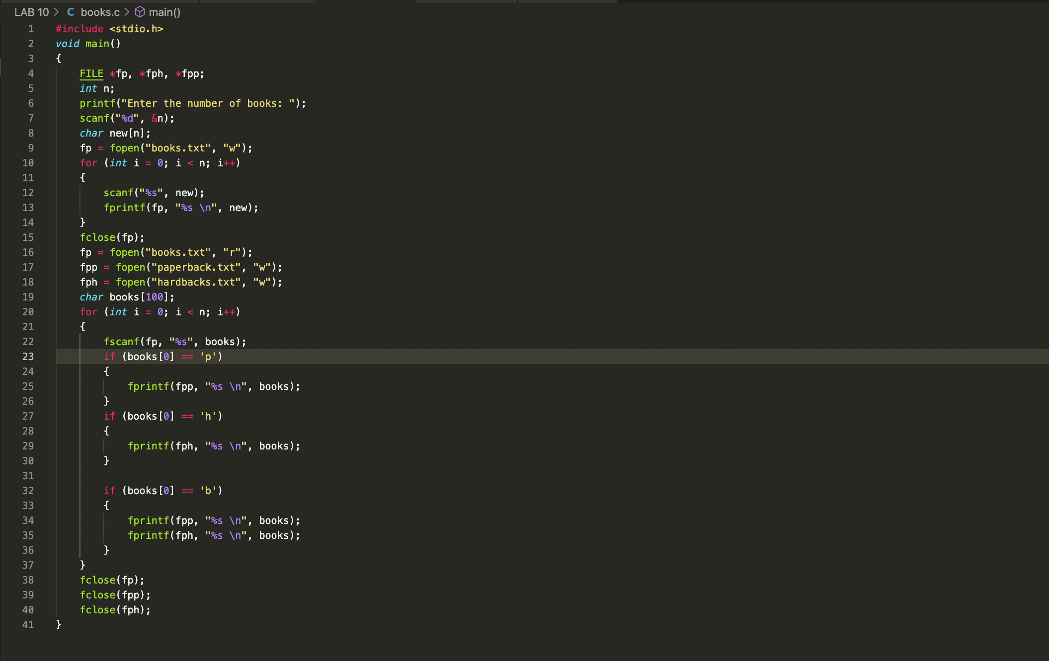
RESULT:
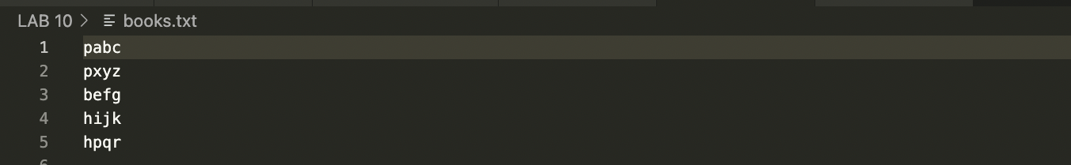
Program 2
PROBLEM STATEMENT : | Set up a file containing vehicle records which hold registration number and owner information (name and address). Write a program which, given a vehicle’s registration number, will rapidly retrieve and print the owner information.
PROGRAM: | 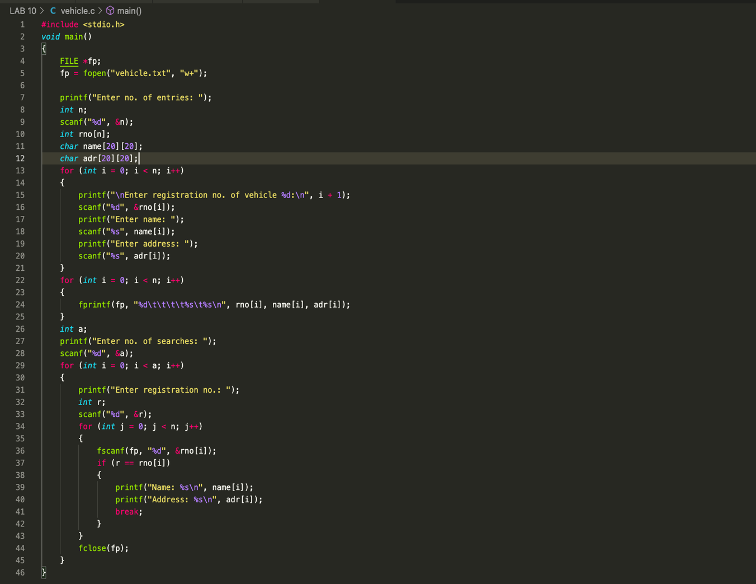
RESULT:
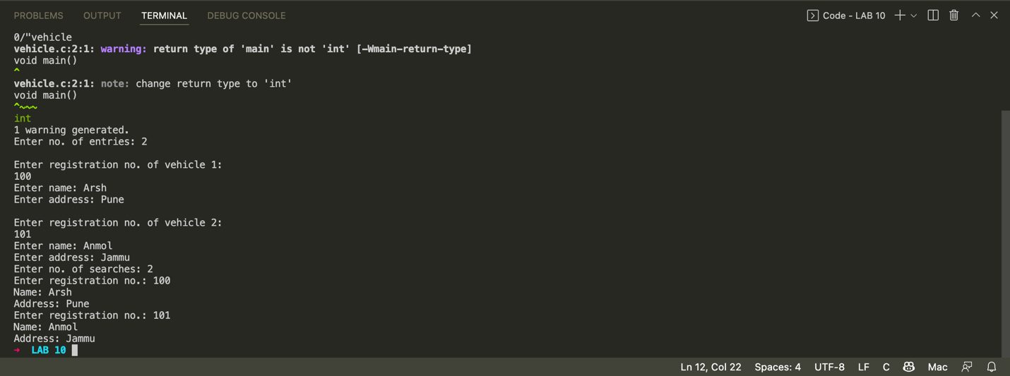
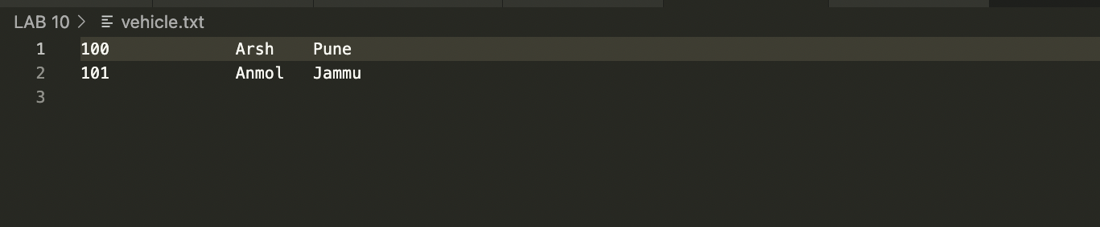
Program 3
PROBLEM STATEMENT: | C program to replace the specified line in an existing text file. Read the line number from the user, and then replace the content-specific line with new text in the existing file. Then print the modified content file.
ALGORITHM: | 1. Start.  2. Open a file File.txt and write some text in it.  3. Ask the user line number of the file to be replaced and relaced text.  4. Open another file New_File.txt.  5. Start a for loop from 1 till the number of lines.  6. If (i) == line_num then write the text given by user in New_file.txt  Else copy the contents of File.txt to New_file.txt line by line.  7. After this for loop copy the entire contents of New_file.txt to File.txt  using fgets and fputs.  8. Close New_File and File.txt.  9. End.
PROGRAM: | 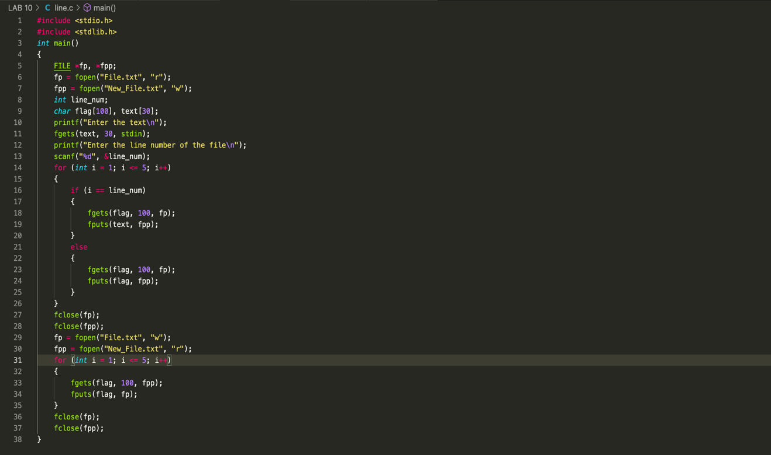
RESULT:

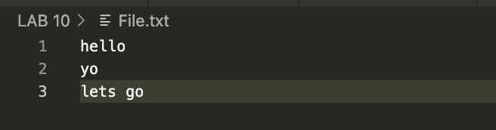
CONCLUSION: | Successfully implemented various operations on files to solve a given problems.

